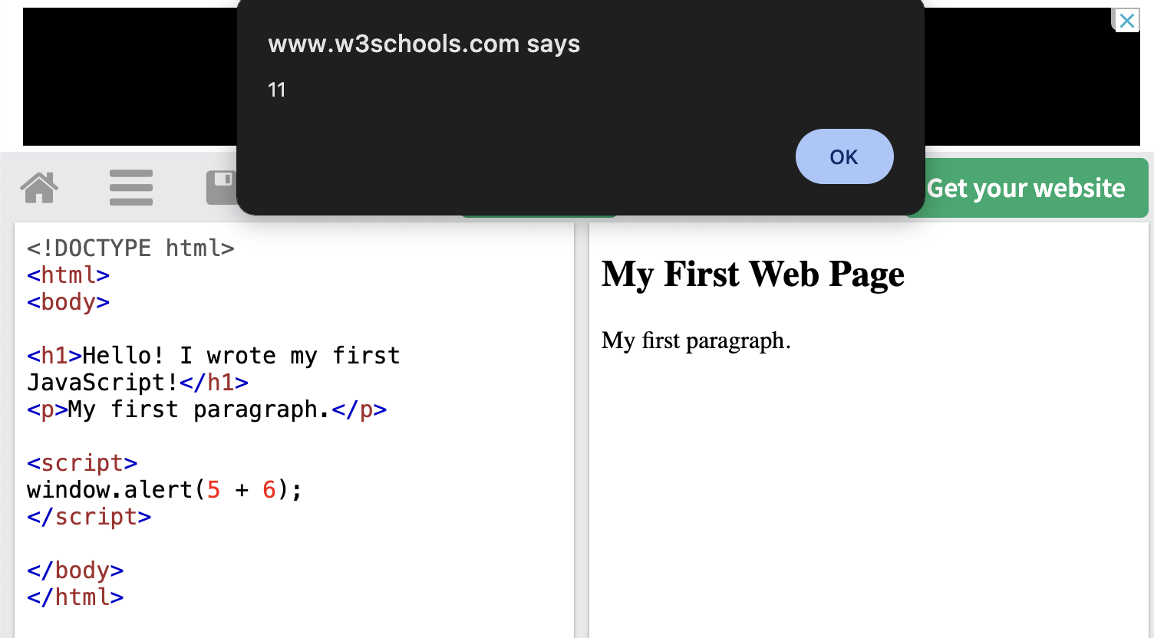

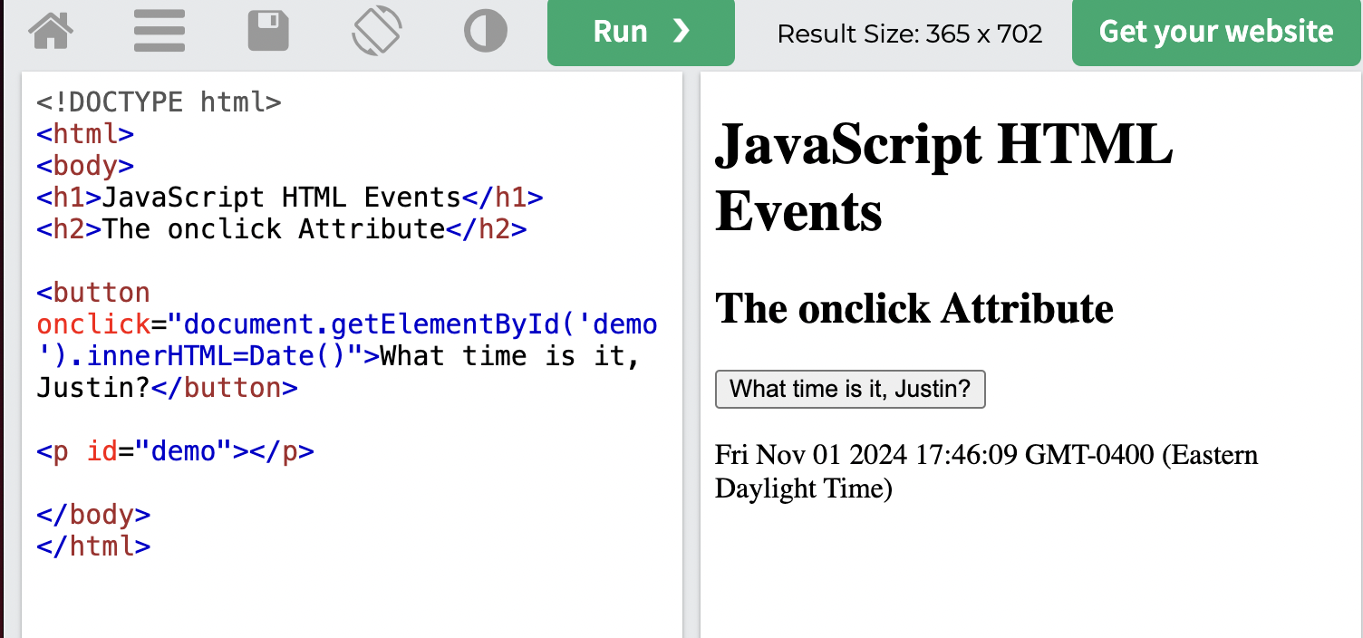

The if and elif conditions have the most control because they have a condition, but the “best control structure” is when they are all used together in sequence. Code blocks that use if, elif, and else structures to work together and make executable determinations are the strongest.